Hamza
24k-3065
Lab-11

Q1:

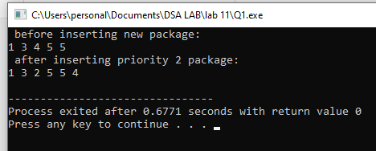
#include <iostream>
using namespace std;

class heap{
public:
int arr[100];
int size;

heap(){
size = 0;
}

void insert(int val){
if(size == 99) return;
size++;
arr[size] = val;

int i = size;
while(i > 1){
int parent = i / 2;
if(arr[parent] > arr[i]){
swap(arr[parent], arr[i]);
i = parent;
} else {
break;
}
}
}

void heapify(int arr[], int size1, int i){
int left = 2 * i;
int right = 2 * i + 1;
int tobesort = i;

if(left <= size1 && arr[left] < arr[tobesort]){
tobesort = left;
}
if(right <= size1 && arr[right] < arr[tobesort]){
tobesort = right;
}

if(tobesort != i){
swap(arr[i], arr[tobesort]);
heapify(arr, size1, tobesort);
}
}

void deleteheap(){
if(size == 0) return;
arr[1] = arr[size];
size--;
heapify(arr, size, 1);
}

void print(){
for(int i = 1; i <= size; i++){
cout << arr[i] << " ";
}
cout << endl;
}
};

int main(){
heap h;

h.insert(3);
h.insert(5);
h.insert(4);
h.insert(1);
h.insert(5);

cout << " before inserting new package:\n";
h.print();

h.insert(2);

cout << " after inserting priority 2 package:\n";
h.print();
}
Q2:

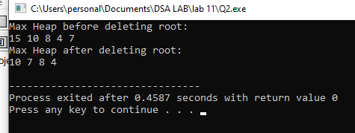
#include <iostream>
using namespace std;

class heap{
public:
int arr[100];
int size;

heap(){
size = 0;
}

void insert(int val){
if(size == 99) return;
size++;
arr[size] = val;

int i = size;
while(i > 1){
int parent = i / 2;
if(arr[parent] < arr[i]){
swap(arr[parent], arr[i]);
i = parent;
} else {
break;
}
}
}

void heapify(int arr[], int size1, int i){
int left = 2 * i;
int right = 2 * i + 1;
int tobesort = i;

if(left <= size1 && arr[left] > arr[tobesort]){
tobesort = left;
}
if(right <= size1 && arr[right] > arr[tobesort]){
tobesort = right;
}

if(tobesort != i){
swap(arr[i], arr[tobesort]);
heapify(arr, size1, tobesort);
}
}

void deleteheap(){
if(size == 0) return;
arr[1] = arr[size];
size--;
heapify(arr, size, 1);
}

void print(){
for(int i = 1; i <= size; i++){
cout << arr[i] << " ";
}
cout << endl;
}
};

int main(){
heap h;

h.insert(10);
h.insert(4);
h.insert(8);
h.insert(15);
h.insert(7);

cout << "Max Heap before deleting root:\n";
h.print();

h.deleteheap();

cout << "Max Heap after deleting root:\n";
h.print();
}
Q5:

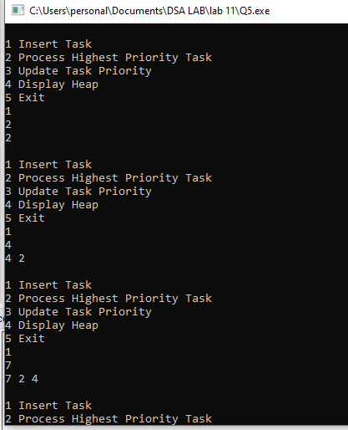
#include <iostream>
using namespace std;

class heap{
public:
int arr[100];
int size;

heap(){
size = 0;
}

void insert(int val){
if(size == 99) return;
size++;
arr[size] = val;

int i = size;
while(i > 1){
int parent = i / 2;
if(arr[parent] < arr[i]){
swap(arr[parent], arr[i]);
i = parent;
} else break;
}
}

void heapify(int arr[], int size1, int i){
int left = 2*i;
int right = 2*i + 1;
int tobesort = i;

if(left <= size1 && arr[left] > arr[tobesort]) tobesort = left;
if(right <= size1 && arr[right] > arr[tobesort]) tobesort = right;

if(tobesort != i){
swap(arr[i], arr[tobesort]);
heapify(arr, size1, tobesort);
}
}

void deleteroot(){
if(size == 0) return;
arr[1] = arr[size];
size--;
heapify(arr, size, 1);
}

void update(int oldp, int newp){
int idx = -1;
for(int i = 1; i <= size; i++){
if(arr[i] == oldp){
idx = i;
break;
}
}
if(idx == -1) return;

arr[idx] = newp;

int parent = idx / 2;
if(idx > 1 && arr[parent] < arr[idx]){
int i = idx;
while(i > 1){
int p = i / 2;
if(arr[p] < arr[i]){
swap(arr[p], arr[i]);
i = p;
} else break;
}
} else {
heapify(arr, size, idx);
}
}

void print(){
for(int i = 1; i <= size; i++) cout << arr[i] << " ";
cout << endl;
}
};

int main(){
heap h;
int choice, x, oldp, newp;

while(true){
cout << "\n1 Insert Task\n2 Process Highest Priority Task\n3 Update Task Priority\n4 Display Heap\n5 Exit\n";
cin >> choice;

if(choice == 1){
cin >> x;
h.insert(x);
h.print();
}
else if(choice == 2){
h.deleteroot();
h.print();
}
else if(choice == 3){
cin >> oldp >> newp;
h.update(oldp, newp);
h.print();
}
else if(choice == 4){
h.print();
}
else break;
}

return 0;
}

